**JAVA ASSiGNMENT-2**

1) Implement a banking system using java. Create 3 sub class of Bank : SBI,BOI,ICICI

Classes should have attributes like Name, headofficeAddress, chairmanName, branchCount, fdInterestRate, personalLoanInterestRate, homeLoanInterestRate. All 3 should have following methods:

* add getters and setters for the fields
* print details of every bank (override toString)

Output 1:

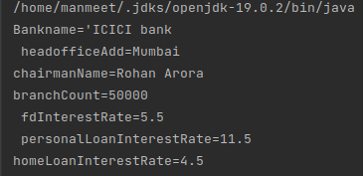

2) WAP showing try, multi-catch and finally blocks.

Output 2:

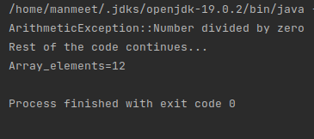

3) WAP to produce NoClassDefFoundError and ClassNotFoundException exception.

Output 3:

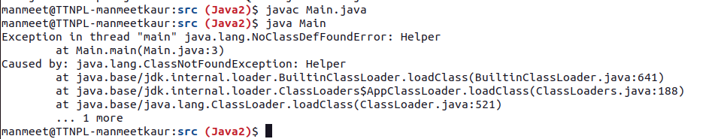

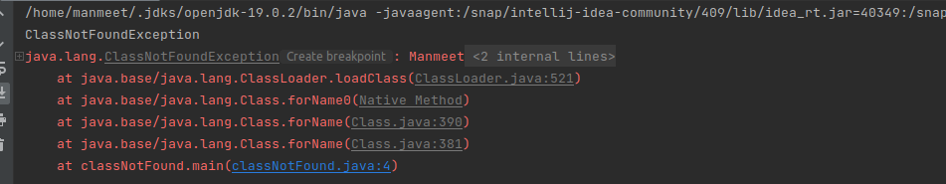

4) Create a custom exception that do not have any stack trace.

Output 4:

